Viewing Report Cards on the Parent Portal
- Log into Parent Portal
- Click the Student that you want to see the report card for
- Click on the App Switcher button
Note: Report Cards will show for all students the parent has access to in the one PDF file
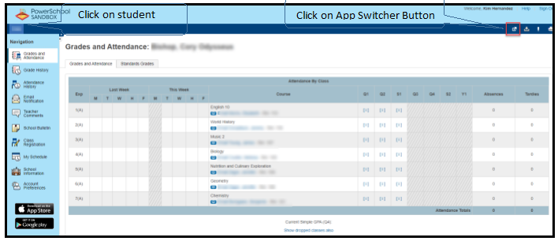
- The application window will open and you can click on District Report Card
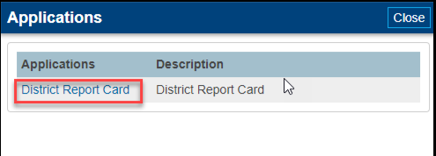
- After clicking on District Report Card, the report card download will show in lower left corner
